**INTERNSHIP CERTIFICATE**

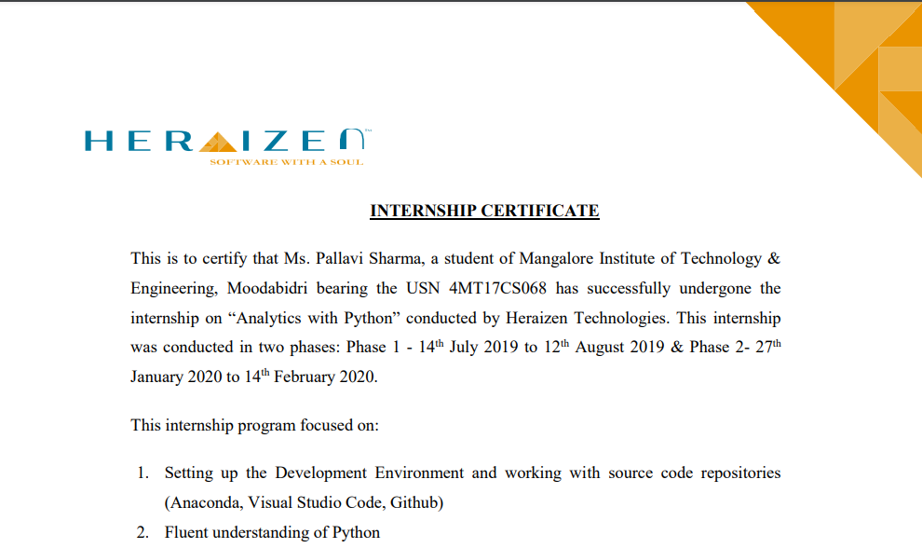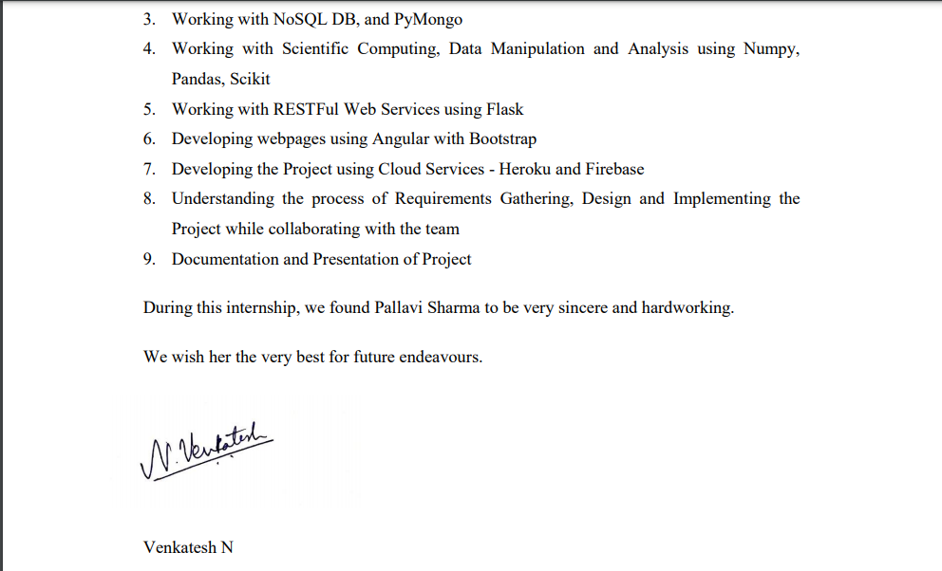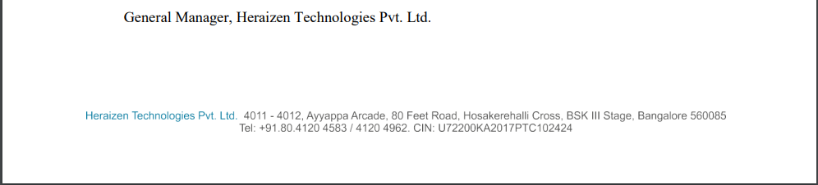

**ABSTRACT**

The Internship was done at Heraizen Technologies Pvt. Ltd. located at Bangalore which is the trusted, digital transformation partner of choice for education campuses, universities, institutes of higher learning, schools and educational institutes of all kinds. This internship focused on understanding of Python, Working with NoSQL DB, PyMongo, RESTFul Web Services using Flask and Developing webpages using Angular with Bootstrap. After the completion of the training the internship was proceeded by the assignment of a project. The project is a part of the existing application called DHI. It is the Real-Time Fully Integrated Digital platform for Education campuses which tracks student performance and has built-in intelligence and analytics for student centric approach based on the concept of outcome based education. The System drives collaboration among students, faculty, management and parents to bring in action based performance improvement.  The project is about identification of courses (top / bottom n) based on CO attainment scores at the course level, considering common rubrics (C3.2.2 A). In this project APIs are built using Flask with MongoDB as a database and Angular Framework is used for building web pages. As a student it was a great experience to work on real-time applications with the professionals as our guides which has helped us to gain knowledge on the web domain. Thank you for providing me with this opportunity.

i

**ACKNOWLEDGEMENT**

The successful completion of any significant task is the outcome of invaluable aggregate combination of different people in radial direction explicitly and implicitly. I would therefore take opportunity to thank and express my gratitude to all those without whom the completion of internship would not be possible.

I express my regards and thanks to **Dr. Venkatramana Bhat P.**, *HOD* of Computer Science Department, MITE for his encouragement and support.

I am obliged to **Mrs. Sumalatha U.**, *Assistant Professor*, who rendered valuable assistance as the project coordinator and guide.

I would like to thank our Dean - Placement and Training **Mr. Narendra U. P.** for his constant support and encouragement to accomplish the internship work.

I am grateful to **Mr. Lakshman**, the employee at Heraizen Technologies Pvt. Ltd. for being a very supportive and encouraging mentor throughout my internship.

I express my sincere gratitude to **Dr. G. L. Easwara Prasad**, *Principal*, MITE who has always been a great source of inspiration.

**Pallavi Sharma**

ii

**TABLE OF CONTENTS**

|  |  |
| --- | --- |
| ABSTRACT | i |
| ACKNOWLEDGEMENT | ii |
| TABLE OF CONTENTS | iii |
| LIST OF FIGURES | iv |
| WEEKLY OVERVIEW OF INTERNSHIP | 1 |

|  |  |  |
| --- | --- | --- |
| **CHAPTER NO.** | **CHAPTER NAME** | **PAGE NO.** |
| 1 | INTRODUCTION TO TOPIC AND OBJECTIVE | 2 |
| 2 | ABOUT THE COMPANY | 3 |
| 3 | TECHNOLOGIES COVERED | 4 |
| 4 | TASK PERFORMED/STUDIED WEEKLY | 7 |
| 4.1 | WEEK 1 | 7 |
| 4.2 | WEEK 2 | 7 |
| 4.3 | WEEK 3 | 8 |
| 4.4 | WEEK 4 | 8 |
| 4.5 | WEEK 5 | 10 |
| 4.6 | WEEK 6 | 11 |
| 5 | OUTPUT OF THE INTERNSHIP | 12 |
| 6 | CONCLUSION | 18 |
| 7 | REFERENCES | 19 |

iii

**LIST OF FIGURES**

i

i

|  |  |  |
| --- | --- | --- |
| **TITLE** | | **PAGE NO.** |
| Figure 5.1 | Selection Criteria Screen for the Faculty | 12 |
| Figure 5.2 | Bar graph of CO’s of all the Courses | 13 |
| Figure 5.3 | Bar graph showing Details of all the CO’s of the selected Course | 13 |
| Figure 5.4 | Accordion table showing the detail of Selected CO | 14 |
| Figure 5.5 | Rubrics Details | 14 |
| Figure 5.6 | RWD of Selection Criteria Screen for the Faculty | 15 |
| Figure 5.7 | RWD of Bar graph of CO’s of all the Courses | 15 |
| Figure 5.8 | RWD of Bar graph showing Details of all the CO’s of the selected Course | 16 |
| Figure 5.9 | RWD of Accordion table showing the detail of Selected CO | 17 |
| Figure 5.10 | RWD of Rubrics Details | 17 |

iv